**ASSIGNMENT 6**

**Project Title:**

Breast Cancer Prediction Using Machine Learning.

**Team Leader:**

Ejumalla Saikiran

**Team members:**

1. Naveen Rampa

2. J Sinduja

3. A. Bhavya Sri

4. S.Lakshanya

5. Nanda Kishore

**Submission Date:**

**23/02/2024**

**Data Analysis on the breast cancer prediction model:**

Based on the provided data and the output from the breast cancer prediction model, here's a report summarizing the findings.

**Uploading Data on Azure Machine learning**

The dataset provided for breast cancer prediction was imported into the azure machine learning platform. Certain columns such as Patient_ID, Date_of_Surgery, Date_of_Last_Visited did not contribute to the objective of computing the prediction and hence were not included.

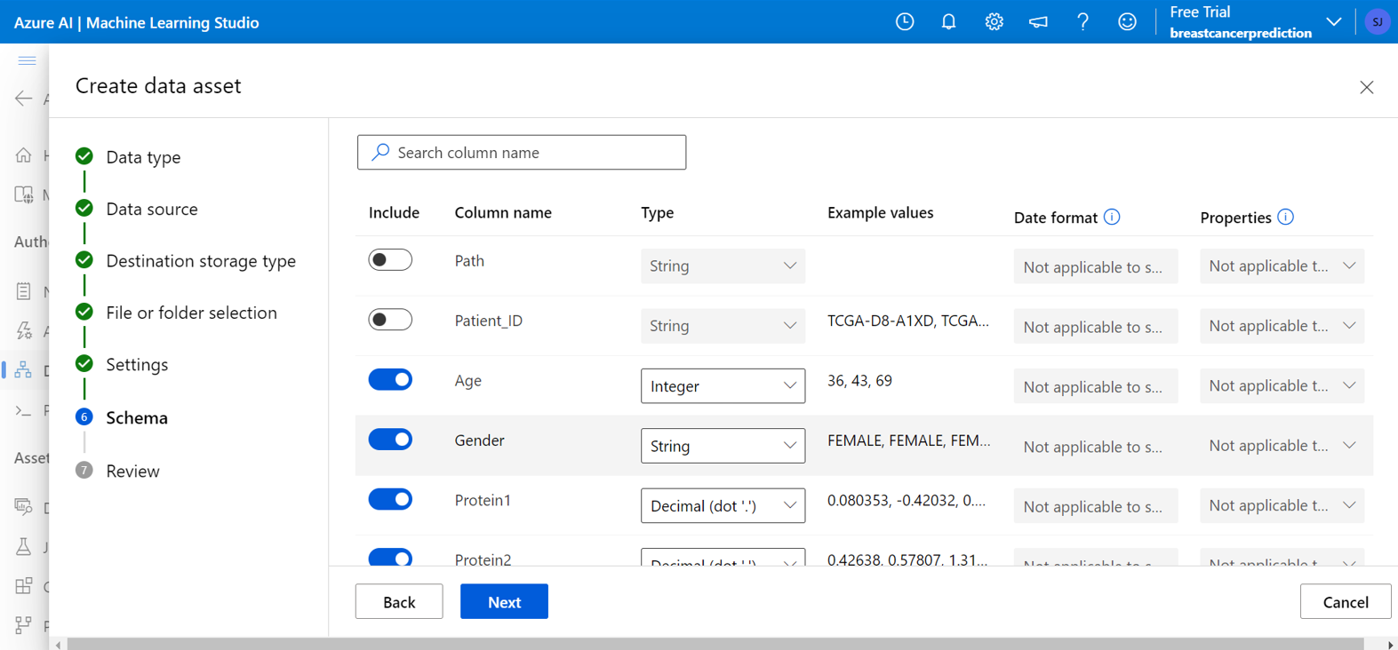

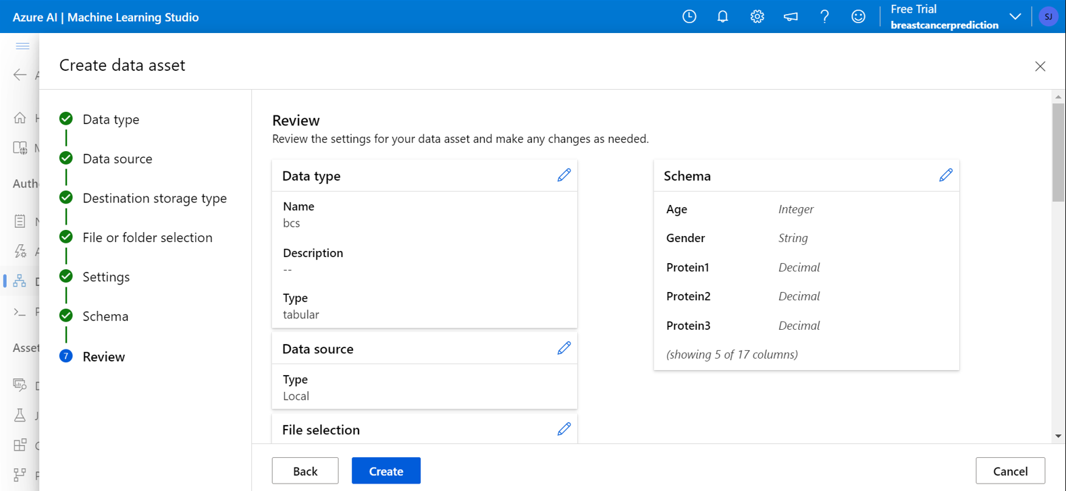

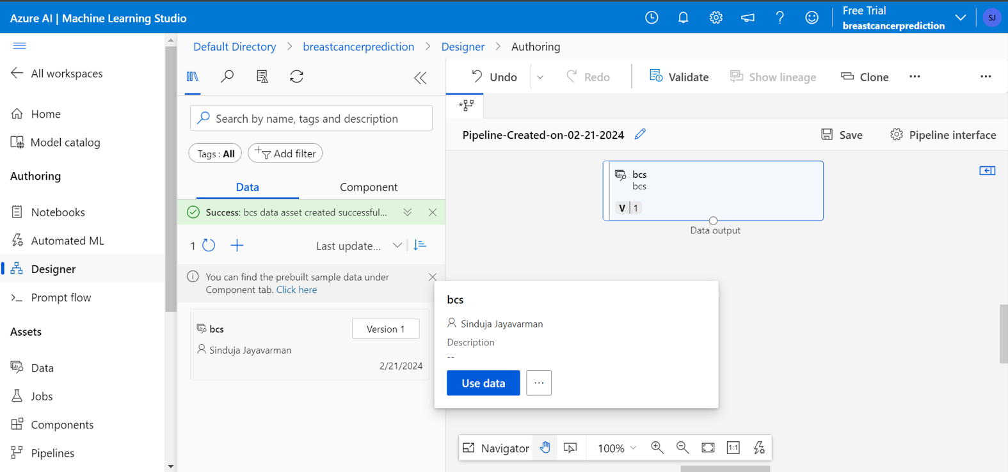

**Creation of Pipeline using designer mode**

In the given data set we have noticed that the target variable has 3 categorical outputs which are dead,alive and null. So we used a Multiclass logistic regression algorithm to build this model. The data was split into a 70:30 ratio to train and test the model respectively.

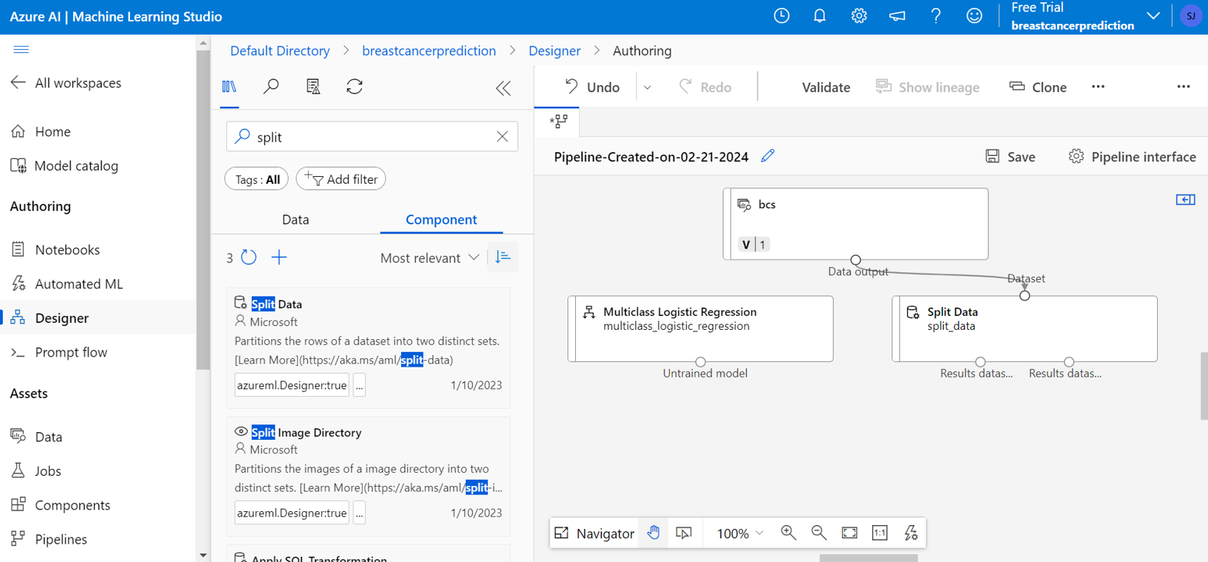

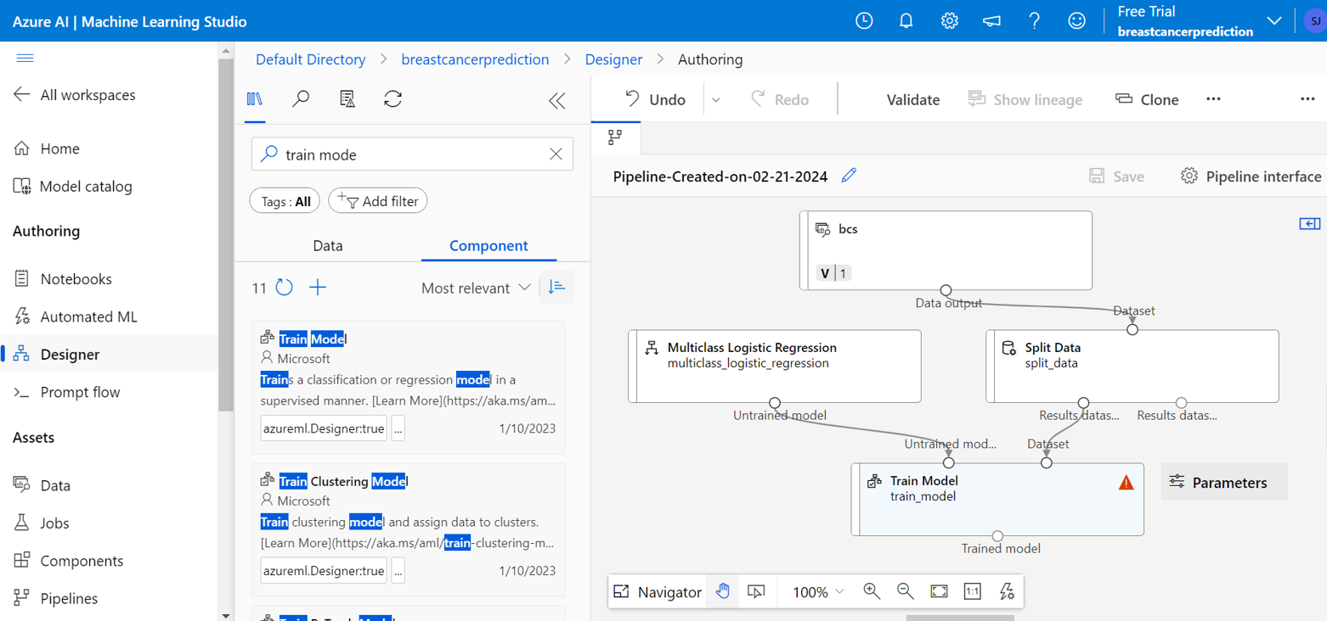

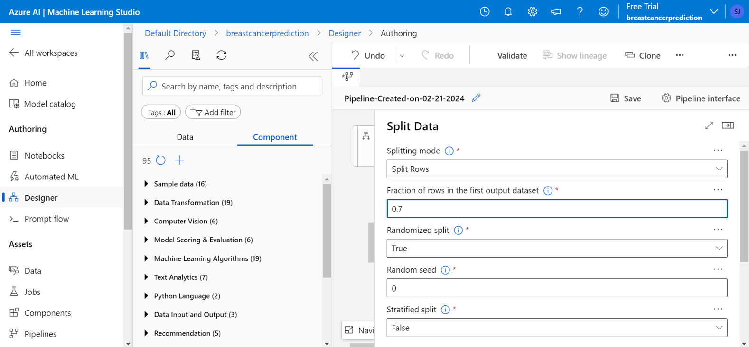

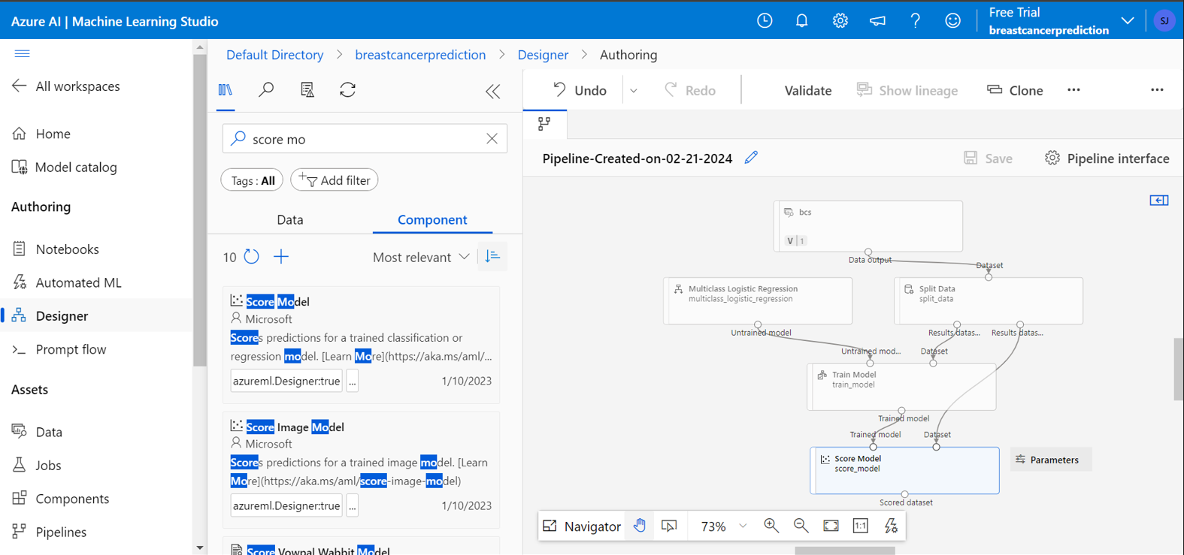

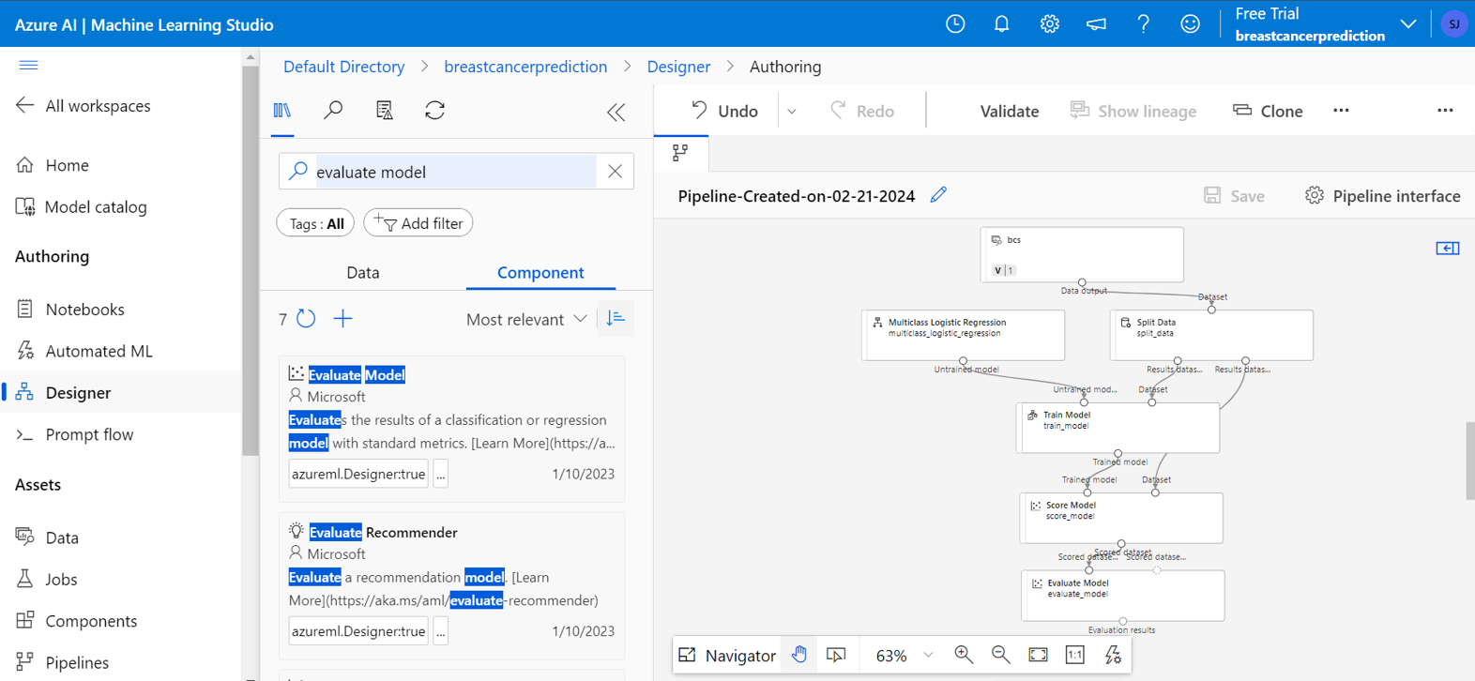

**Creation of Inference Pipeline**

After creation of piepline model we proceeded to creation on Inference pipeline model which is basically needed for services such as real time input and output.

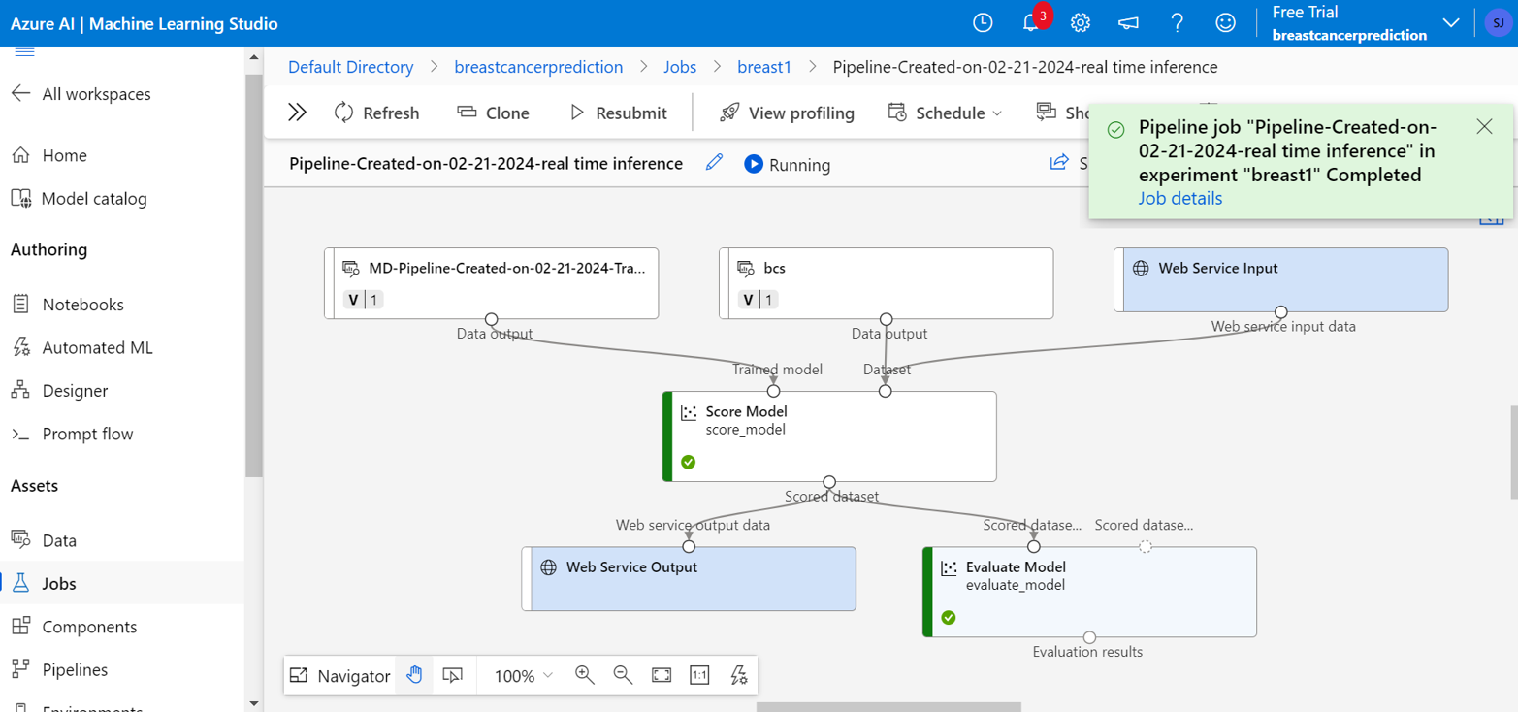

**Creation of AksCompute Instance and deployment of model**

AKsCompute Instance was created instead of kubernetes cluster because of the limited dataset and the model was deployed successfully .

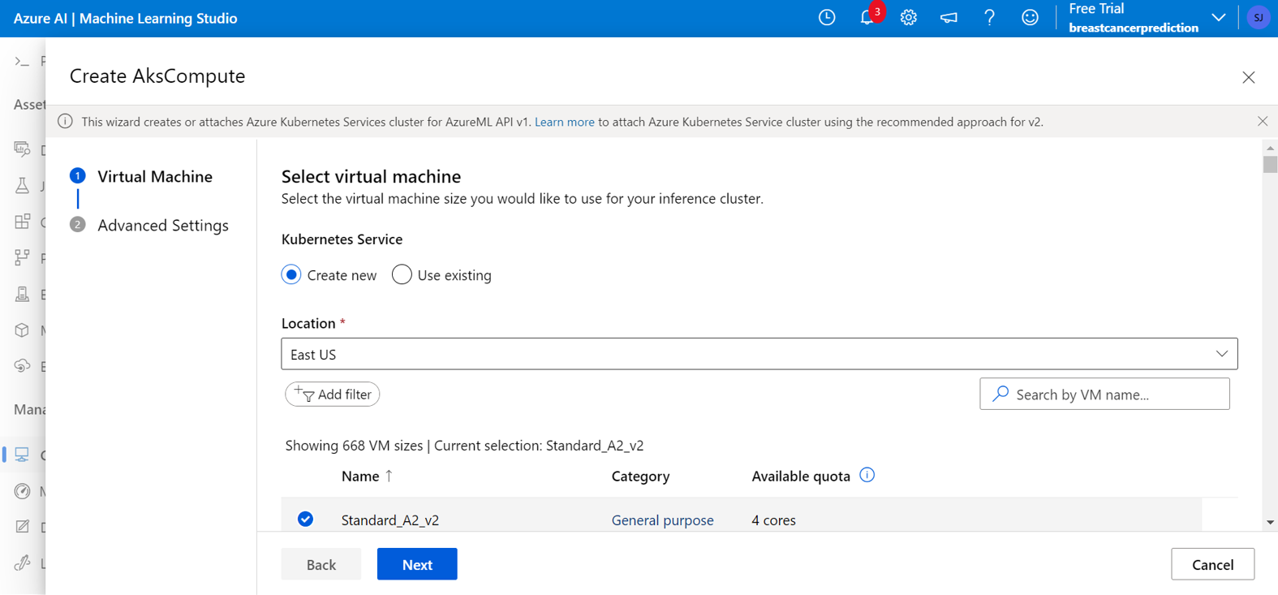

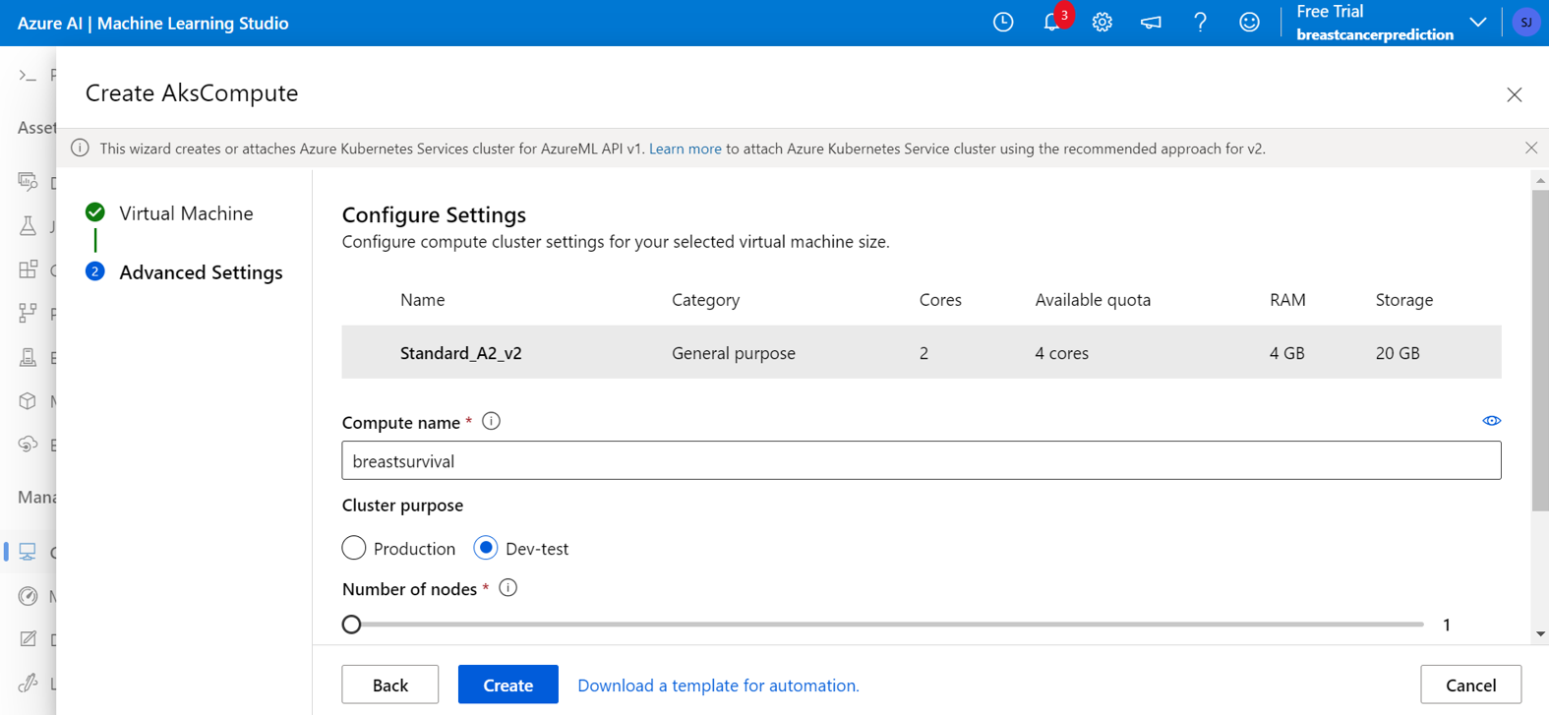

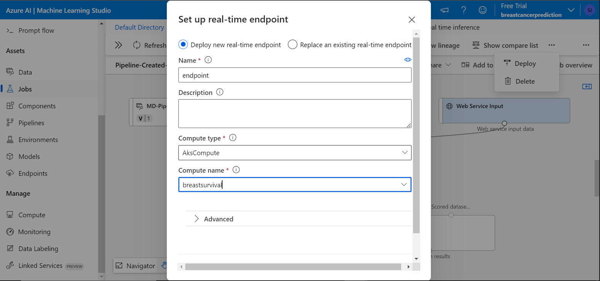

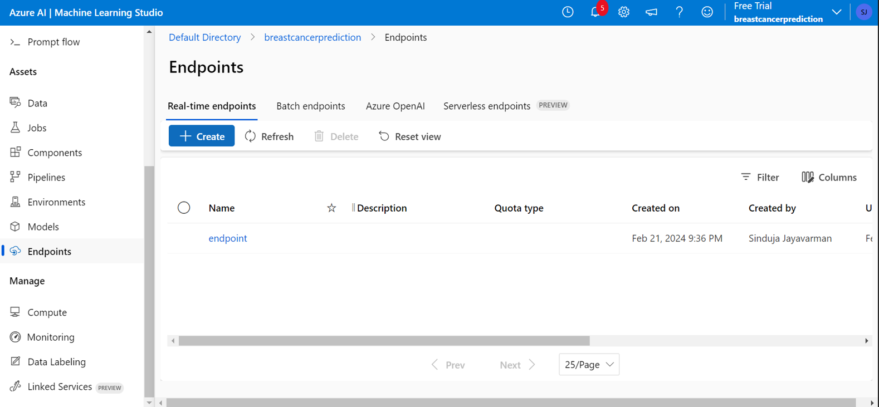

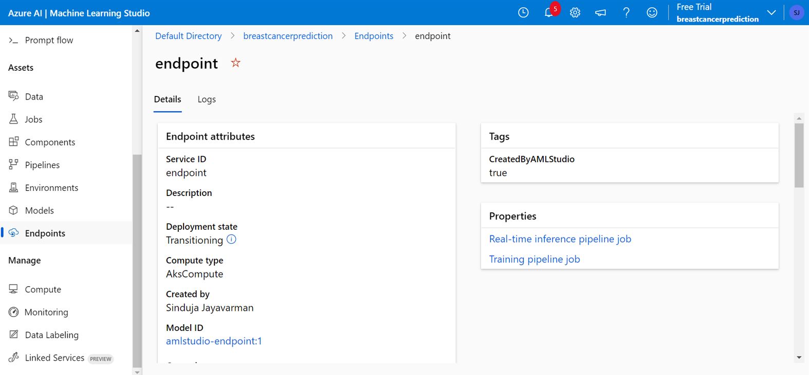

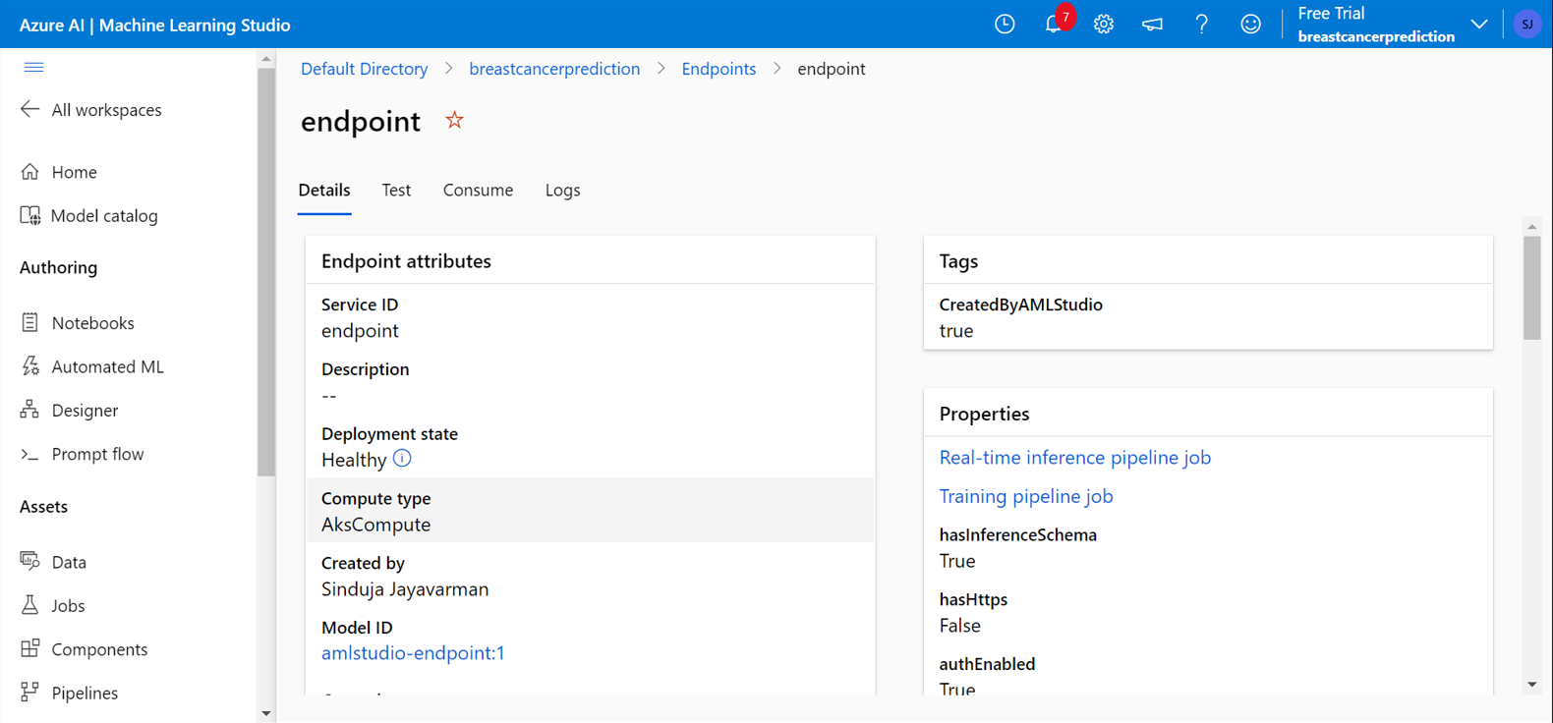

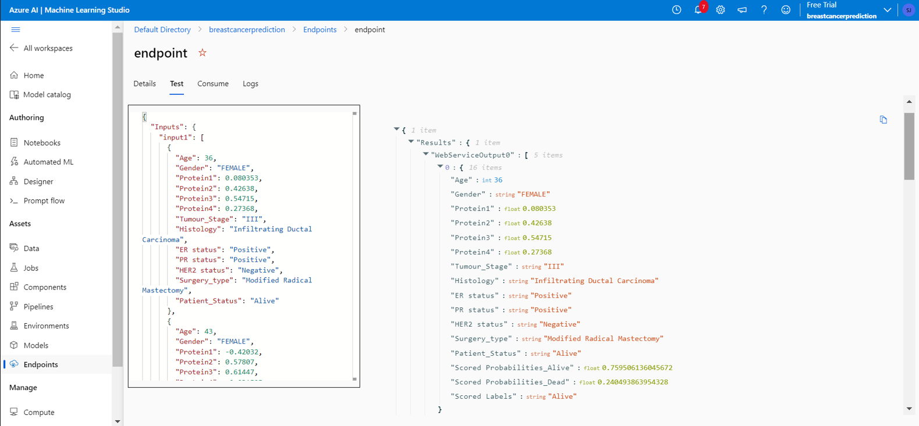

**Conclusion**

So,from the results, we can observe that the accuracy of the model was decent in prediction of some cases, but due to insufficient data regarding deceased cases within the provided dataset, the model's predictions for fatalities are not sufficiently accurate, rendering it unsuitable for full-time deployment.